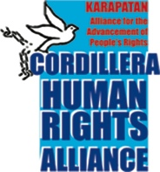
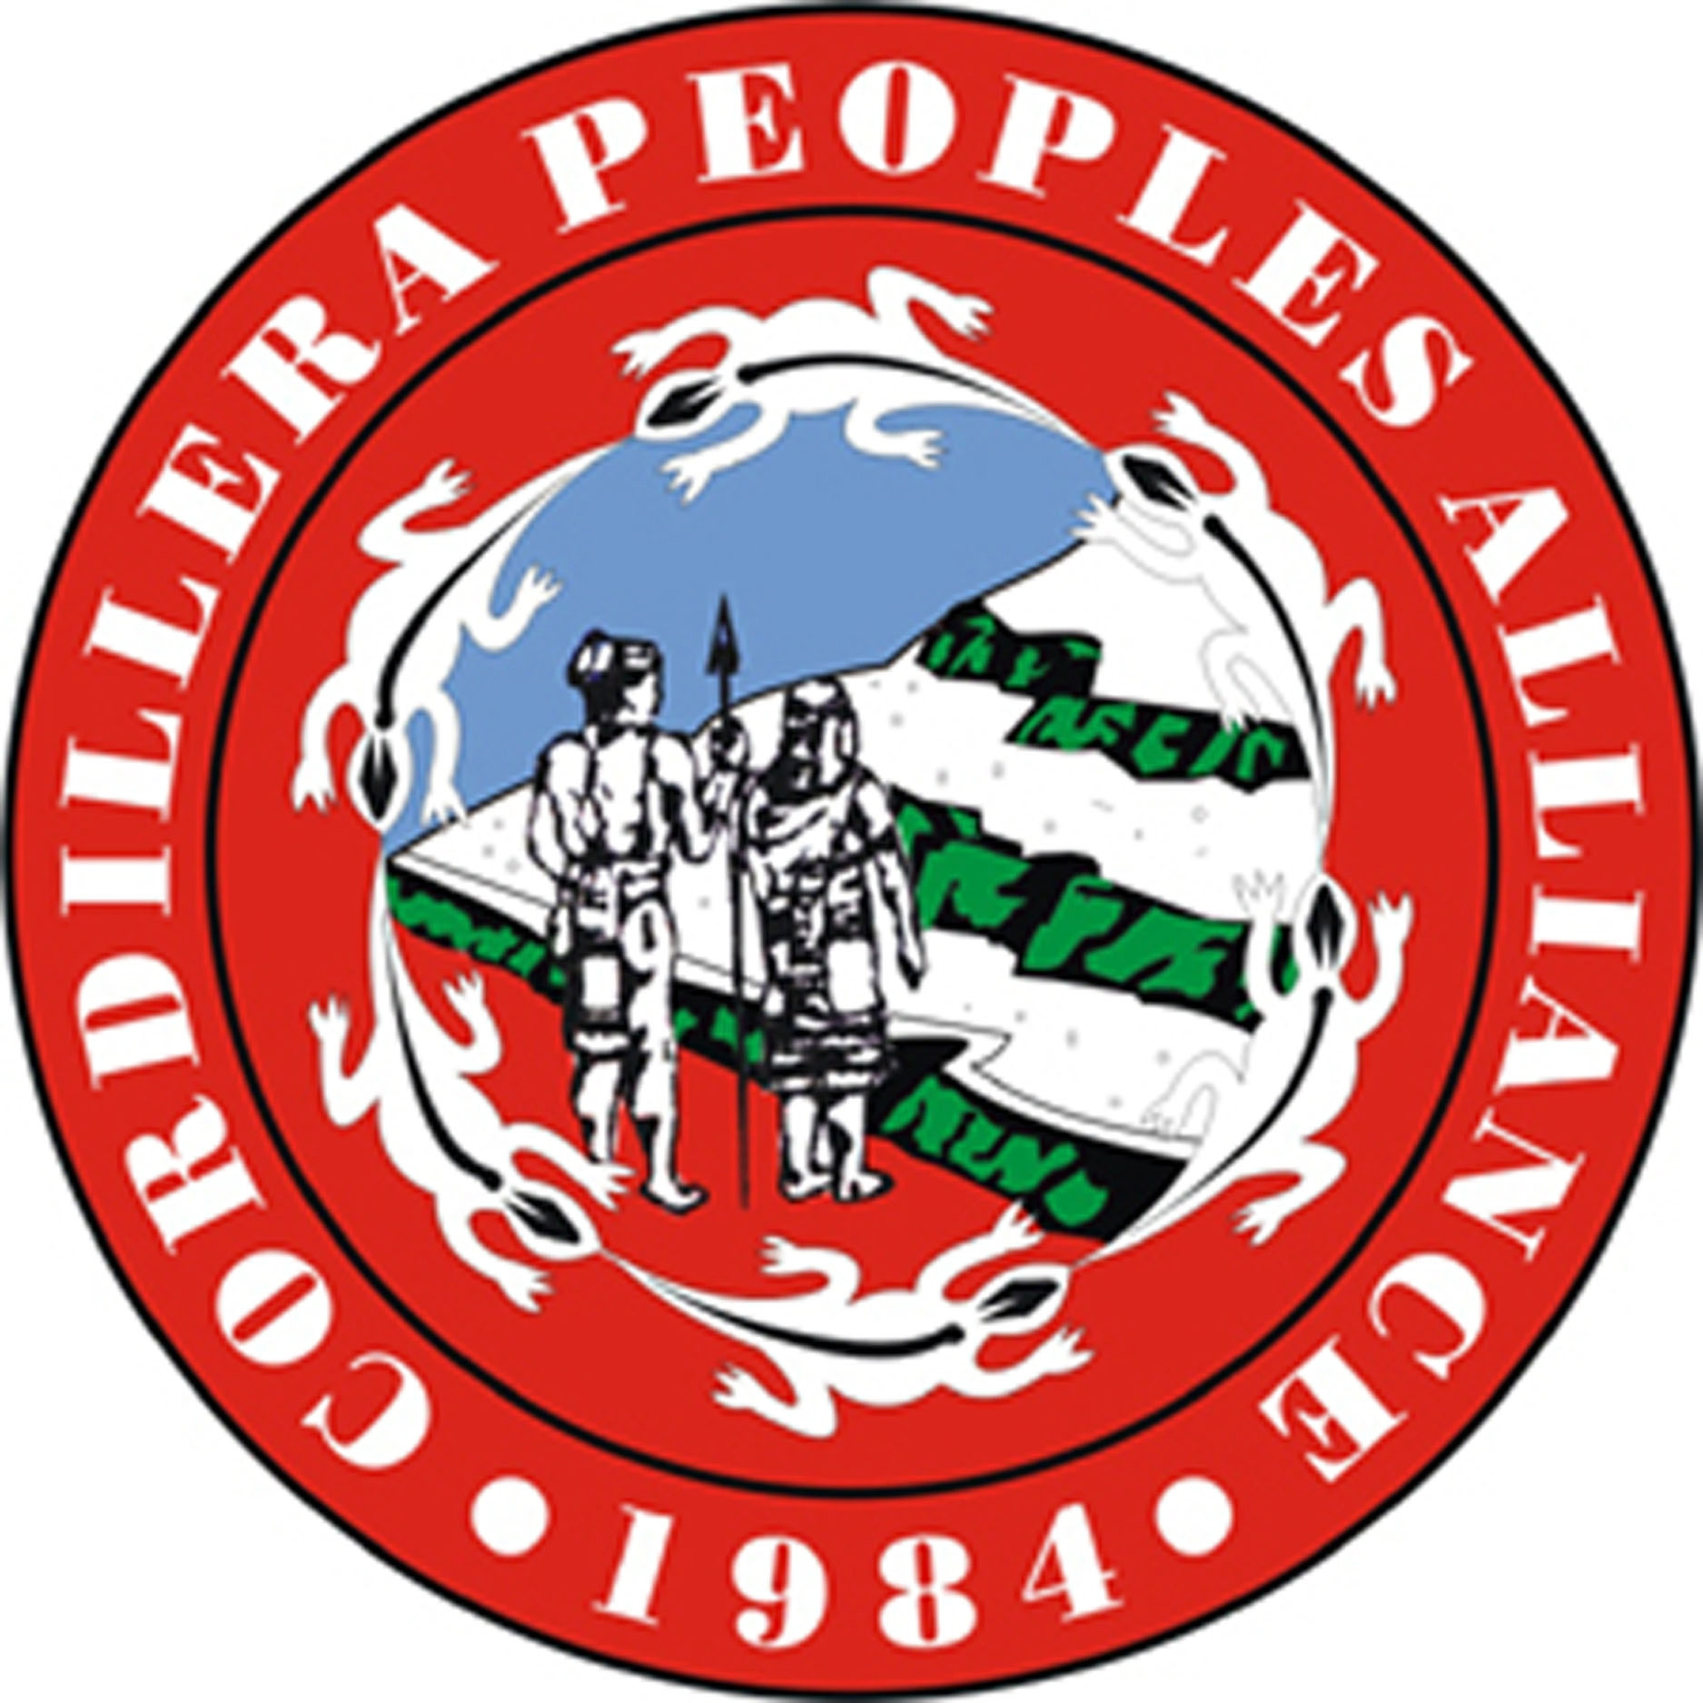

13 February 2017

Urgent Appeal: Stop the attacks against Indigenous Peoples and human rights defenders. Drop the trumped-up cases filed against Igorot activist Sarah Abellon-Alikes!

Sarah Abellon-Alikes, a Kankanaey-Igorot who hails from Mountain Province in the Cordillera region, Philippines, was illegally arrested by the Armed Forces of the Philippines (AFP) at 9 o’clock in the morning of February 9 while she was on her way to downtown Baguio City. For two days, she was unjustly detained without charges after she was turned over by the AFP for custodial detention of the Philippine National Police. In the afternoon of February 11, trumped-up cases of arson and robbery were filed against her, after which she was temporarily released on bail.

Sarah is a pioneer of the Cordillera People’s Alliance (CPA) and has dedicated most of her life to organizing indigenous communities for the protection of our ancestral lands and the environment against destructive projects, such as large mines and dams. She has also been delivering development services to marginalized communities not only in the Cordillera but the whole of Northern Luzon as a member of the Board of Directors of the Regional Development Center - Katinnulong dagiti Umili ti Amianan (RDC-Kaduami).

A peace advocate whose father was the late Bishop Richard Abellon, Sr. of the Episcopal Church of the Philippines, Sarah has been actively campaigning against the continued human rights violations, heavy militarization of Cordillera communities, and political repression. She supports the peace talks between the Government of the Philippines (GPH) and the National Democratic Front of the Philippines (NDFP) as she believes this addresses the issues of Cordillera indigenous peoples and the roots of the armed conflict in the country.

The Cordillera region has long been a target of the State and transnational corporations for extractive projects. At least 118 energy project applications and 102 mining applications are currently under process, on top of existing 3 large mines and 3 mega-dams. The peoples’ resistance against the plunder of our ancestral lands is continuously met with militarization and various cases of human rights violations. Military operations and encampment inside indigenous communities continued even with the government ceasefire from August 2016 to January 2017.

We strongly condemn the unlawful arrest, unjust detention and the filing of trumped-up charges against Sarah Abellon Alikes. This came two days after the Duterte government declared an “all out war” against the New People’s Army, which in our experience means intensified fascist attacks against the people and militarization of indigenous communities. The unjust treatment of persons defending the people’s interests and welfare, indigenous peoples’ rights and human rights must end.

We call on all peace-loving people to urge the Philippine government to:
- Drop the trumped-up charges of arson and robbery filed against Sarah Abellon Alikes;
- Stop the political persecution of indigenous communities, activists and development workers;
- Stop the militarization of indigenous communities and pull out AFP troops and paramilitary from our ancestral domains;
- Stop the All-Out War;
- Continue the peace talks to address the issues of the people. Respect and implement the gains that were made in the three rounds of the peace talk and the agreements that have been signed between the GPH and NDFP;
- End counter-insurgency programs like Oplan Bayanihan and Oplan Kapayapaan;
- Pursue its commitment for a Comprehensive Agreement on Social and Economic Reforms (CASER) that will comprehensively tackle the deeply-rooted feudal relations in the country, move towards free land distribution of monopolized lands and the recognition of indigenous peoples rights to ancestral lands and territories;
- Pursue its commitment to the Comprehensive Agreement on the Respect of Human Rights and International Humanitarian Law (CARHRIHL) which includes the right of peasants, indigenous communities, and environmental protection; and
- Adhere to the Universal Declaration of Human Rights, United Nations Declaration on the Rights of Indigenous Peoples (UNDRIP) and all the major Human Rights instruments that it is a party and signatory of.

You may send your communications to:

H.E. Rodrigo Duterte
President of the Republic
Malacañang Palace,
JP Laurel St., San Miguel
Manila Philippines
Voice: (+632) 564 1451 to 80
Fax: (+632) 742-1641 / 929-3968
E-mail: op@president.gov.ph or send message through http://president.gov.ph/contact-us/

Hon. Jesus Dureza
Presidential Adviser on the Peace Process
Office of the Presidential Adviser on the Peace Process (OPAPP)
7th Floor Agustin Building I
Emerald Avenue
Pasig City 1605
Voice:+63 (2) 636 0701 to 066
Fax:+63 (2) 638 2216
Email: stqd.papp@opapp.gov.ph, feedback@opapp.net

Ret. Maj. Gen. Delfin Lorenzana
Secretary, Department of National Defense
Room 301 DND Building, Camp Emilio Aguinaldo,
E. de los Santos Avenue, Quezon City
Voice:+63(2) 911-6193 / 911-0488 / 982-5600
Fax:+63(2) 982-5600
Email: info@dnd.gov.ph, webmaster@dnd.gov.ph

Hon. Vitaliano Aguirre
Secretary, Department of Justice
Padre Faura St., Manila
Direct Line 521-8344; 5213721
Trunkline: 523-84-81 loc.214
Fax: (+632) 521-1614
Email: communications@doj.gov.ph

Hon. Jose Luis Martin Gascon
Chairperson, Commission on Human Rights
SAAC Bldg., UP Complex, Commonwealth Avenue
Diliman, Quezon City, Philippines
Voice: (+632) 928-5655, 926-6188
Fax: (+632) 929 0102
Email: chairgascon.chr@gmail.com

Thank you for your support!

Please send us a copy of your email/mail/fax to the above-named government officials. For more information, contact:

Windel Bolinget Imelda Tabiando
Chairperson Secretary General
Cordillera Peoples Alliance Cordillera Human Rights Alliance
Email: cpa@cpaphils.org Email: chra.karapatan@gmail.com
Telephone: (63) 74 422 9754

